27 The Avenue
Totland Bay
Monday 10th February 2020
PO39 0DH
Tel 754607
Dear Mr Seely,
Thank you for your conference call on Thursday 6th Feb at 13:00. Thank you for agreeing to ask questions of relevant ministers regarding the regulation of acid stimulation and acid fracking in onshore oil and gas wells. Given the possible restructuring of ministers and government departments it may not be DEFRA that is the best one to contact. May I suggest that you also appeal to the EA, BEIS and the OGA for answers to your questions. Questions are attached separately as a pdf document

Introductory statement
UKOG have stated in their EIA screening report that they will be using only “acid washes” in their plans for Arreton exploration and that these plans and wells will be a look-alike for what they are doing in the Weald and currently at Horse Hill.
In their brochure they state that they will not be using HYDRAULIC FRACKING or acid stimulation / acid fracking techniques in the Arreton exploration project. We believe the first part of this statement to be true given the targeted Portland strata for exploration. However for appraisal and production from the Portland and Kimmeridge strata this is a different issue.

We believe that they probably have used such techniques in the past at their Broadford Bridge and Horse Hill sites, given the impermeable nature of the strata and because of evidence garnered from UKOG’s RNS , competent person statements, in video interviews and company presentations.

Our concerns are that, during appraisal and production phases at Arreton and Godshill, there is no way that regulators can know whether they will be using acid stimulation /acid fracking or not, because of the omission of lawful definitions of acidisation, inadequacies in enforcement of this process and the current operator’s self- regulatory system for onshore wells.
Additionally the Newdigate Swarm of earthquakes last year is still under independent scientific scrutiny, despite the BGS statement that the cluster of earthquakes were “probably” not related to UKOG activity at Horse Hill.

For these reasons I consider it disingenuous that these forms of extreme oil and gas extraction from onshore wells are not recognised under the Infrastructure Act as harmful and are not enforced under the current regulatory system.
I do hope that you managed to read or have been briefed about the Legal Brief - Acid Stimulation - Fracking by Stealth submitted with my email appeal to you on 3rd November 2019 asking if you would sign the Brockham Oil Watch letter to government regarding changes to regulations and inclusion of acid stimulation in the moratorium. https://brockhamoilwatch.org/4993-2/ I note that you did not sign it.
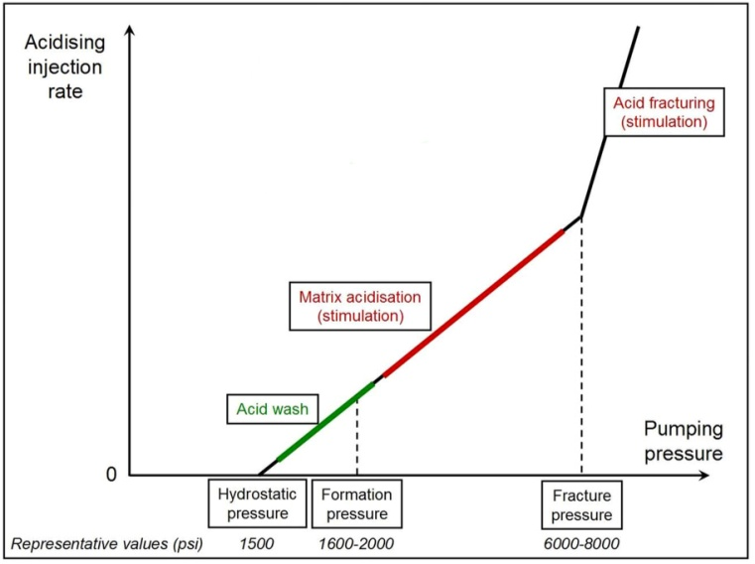
Quoted from the 2018 EA Guidance document - Use of acid at oil and gas exploration and production sites
“Acidisation is a term used in the oil and gas industry for different activities using diluted acid. It involves pumping acid into a drilled well or geological formation that is capable of producing oil and/or gas.
The purpose of acidisation is to clean out the well following drilling and to improve the productivity of the well. The term acidisation can include acid washes, matrix acidisation and fracture acidisation.

An acid wash is used to clean the well following drilling, or to clean it after a period of use.
The Environment Agency does not consider an acid wash to be a well stimulation method.
Matrix acidisation involves pumping dilute acid into the oil and / or gas reservoir from the well. The acid is injected, or “squeezed”, in to the geological formation at a pressure that is above the geological formation pressure but below the formation fracturing pressure.
The Environment Agency does consider matrix acidisation to be a form of stimulation.
Fracture acidisation involves pumping dilute acid into the oil and / or gas reservoir from the well.
To enable fracture acidisation the acid is pumped in to the well at pressures above the geological formation fracturing pressure. The pressure applied, which will be above the geological formation fracturing pressure, enables the rock to be fractured as well as to be dissolved.
The Environment Agency does consider fracture acidisation to be a form of stimulation.”

See Question 1 of attachment.

“How do we control and determine if a proposal is acceptable?
The Environment Agency will discuss the initial proposals with the operator, or their consultants, review the technical information submitted in any pre-application documents or in environmental permit application documents.
We base our assessment and determination on the information submitted.”

There is no legal requirement for monitoring for enforcement. The EA relies solely on what the operator tells them they plan to do. So they cannot know what is happening underground. Furthermore reports to the OGA do not require evidence of details of any fluid analysis.

See Question 2 of attachment.

The Petroleum Act 1998 guidance suggests that “Associated Hydraulic Fracturing” is subject to various restrictions. The OGA states that a Hydraulic Fracturing Plan will always be required for hydraulic fracturing of wells but that less information may be required if the activities do not meet the volume thresholds set out in the 1998 Petroleum Act for “associated hydraulic fracturing” including the amount of fluids used in the drilling process

OGA guidance also demonstrates various circumstances that will not require an Hydraulic Fracturing Plan.
In particular, it demonstrates that a “completion acid wash” carried out at below fracture strength with 15% concentration of hydrochloric acid without proppant but with flow back fluids that require disposal at an appropriate facility will not require a Hydraulic Fracturing Plan.
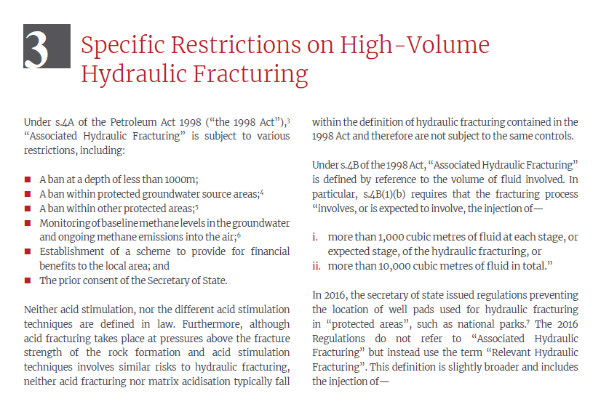
Extracted from “ Acid Stimulation - Fracking by Stealth”

Acid stimulation - both acid fracturing and matrix acidisation typically uses less fluid than high-volume hydraulic fracturing and these stimulation techniques therefore fall outside the definition contained in both the 1998 Act and the 2016 Regulations.
See Questions 3 and 4 of attachment

Thank you for your consideration to give your support in this matter.
Please can you notify me of receipt of this letter and indicate if you are able to move forward with these proposals.

Kind regards,
Sylvia May (Lead Research and Community Outreach for Frack Free Isle of Wight.)

